*”Civil Society has won many battles. But we are still losing the planet. It’s important to ask why.” Gustav Speth*

# Call for participants

## Transformative Learning Journey:

## Tackling the Root Causes if Global Crises through Education

## October 2019 – June 2020

## The Context: About Bridge 47 – Building Global Citizenship

*Bridge 47 – Building Global Citizenship* is a project co-created and implemented by 13 European and 2 global civil society organisations. It seeks to mobilise and empower civil society and change makers worldwide to contribute to a transformation towards global justice through Global Citizenship Education (GCE). The name Bridge 47 refers to Target 4.7 of the Sustainable Development Goals which demands the promotion of GCE for all learners. The project builds a global coalition to forward this goal – the Bridge 47 Network. It creates learning spaces for strategizing on joint advocacy work, for exploring new partnerships and for experimenting with innovative approaches of transformative education.

## Our call for a Transformative Learning Journey

For several decades civil society organisations, social movements and activists throughout the world have struggled for the change of global economic systems and power structures that are exploitive of people and nature, dreaming of a world where all people and beings can thrive. Despite all efforts and some success stories, we feel that we live in evermore challenging times. In the light of this, we see the need to critically reflect and possibly re-imagine and change the way we go about education and activism.

According to the diagnosis of Nigerian philosopher Bayo Akomolafe *the problem is not the system but the culture that built the system*. By *culture* he refers to the dominant story of eurocentric modernity as technology driven development based on rational thinking that in the last 500 years has overrun the multitude of different models of co-existing on earth and has programmed us to think and even feel and interrelate in certain limited ways. Accordingly, many of civil society’s solutions to the problems of our world and many educational offerings are based on the same paradigms that created the problems in the first place – and therefore tend to reproduce them. We struggle to find solutions that are fit to lead us to a wiser future.

In this sense of a predominantly *cultural* crisis that underpins our multiple system crises, questions about education and activism emerge:

* What are the (cultural) root causes of global crises?
* What are the mechanisms and power structures of dominant systems that we want to change?
* What is systemic change and what are our points of leverage to foster change?
* How can we develop different and positive narratives of change?
* How can we relate to different knowledge systems and practices to broaden our imagination and decolonize our minds, hearts and doings?
* How can education go beyond rational thinking and cognitive learning, inviting the wisdoms of our hearts and bodies?
* How can education foster a process of self-liberation from the boxes that we think are the limits of what is knowable, tangible and doable?
* How can education help us to re-connect with what and whom we are separated from?
* How can education create space for experimenting with different possibilities of co-existing with each other and natural systems?
* How can education be transformative without becoming overwhelming or indoctrinating?
* How can we acknowledge that there is no masterplan for a better future and that we do not have all the answers but, despite this uncertainty, actively work towards possible futures?

Bridge 47 wants to create a space for exploring these and other questions by inviting you to join the Transformative Learning Journey**.** This is a one year long intensive training for 22 educational practitioners and activists from around the world. It is a unique learning opportunity for those who are already engaged in theory and practice of education for societal transformation but want to dive deeper into the matter and experiment with different practices as part of a learning collective. The course will not prescribe *one* different or better way of doing things but rather invite for a multitude of perspectives and approaches, appreciating the diversity of the group. After having completed this journey, we envision participants to have an increased ability to become stronger leaders of systemic change in their own organisations, networks and social contexts, and to unfold the transformative and empowering potential of their educational practice.

## Who is invited to participate?

Role, capacity and background of the participants

Bridge 47 calls you to embark on the journey with us if…

…you are a staff member from a civil society organisation that is engaged in the field of Global Citizenship Education or a related educational field (such as Global Education, Education for Sustainable Development, Human Rights Education, Diversity Education, Nature Education, Peace Education etc.)

OR

…you are a change maker / activist from any other part of society who mainly works with education as a tool to facilitate transformative change;

AND

…you have the capacity / mandate to multiply the learnings from the journey and induce systemic changes in your organisation or working fields;

...you are committed and have the time to attend all physical meetings, conduct a research and action experiment and actively partake in the online based learning activities.

Motivation of the participants

This journey is for you if…

...you feel the need for fundamental changes in our current economic, social and political system and its cultural foundations; if you believe in a strong role of education to support systemic change;

...you have critical questions towards current concepts and practices of education and seek to make your and your organisations educational work more transformative, empowering and emancipatory and/or share your wisdom with others;

...you are curious, will not be satisfied with easy answers and do not expect ready-to-use tools but are ready to explore new and different questions and embark on experimental actions in a collaborative learning journey.

## Structure and educational approach of the journey

*The journey is more important than the destination...*

The Journey is based on the principle of experiential learning through reflected action. It is comprised of several physical workshops and webinars, as well as online mentoring, individual research, and an action experiment conducted by the participants in their own working context.

The journey creates spaces for participants to reflect upon their own educational practice and underpinning theories of change. By learning from a group of peers and through reflected action participants can move towards a more meaningful and transformative practice – on a personal, organisation and societal level.

The journey itself seeks to offer participants a transformative learning experience, by applying holistic, multi-sensual and interactive methodologies and creating immersions into different knowledge and learning systems. We will work e.g. with storytelling, arts, theatre and embodied exercises and possibly leave the comfort zone of what we know as conventional Global Citizenship Education.

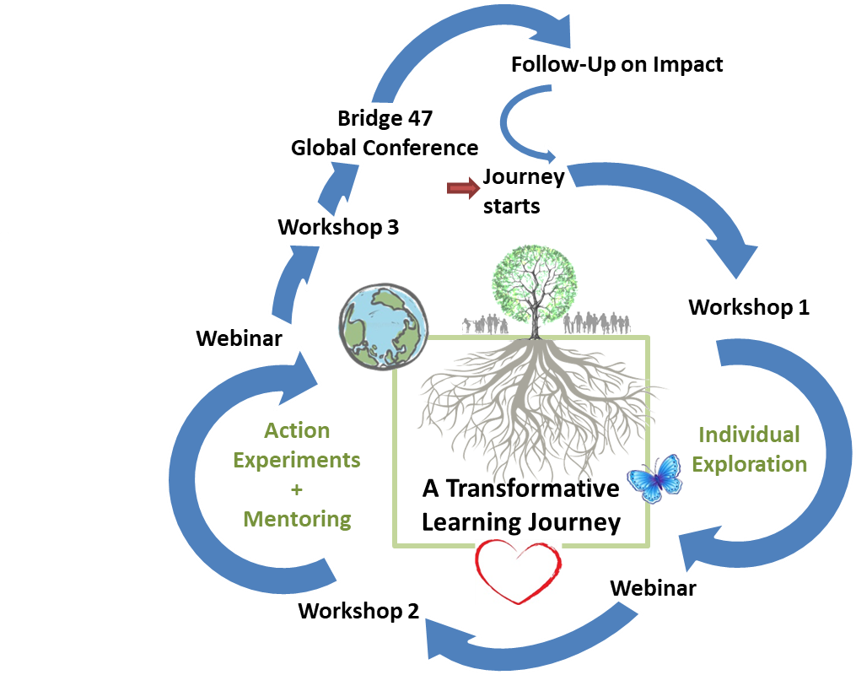

## Course content and timeline

(Please note: Content may be subject to changes)

|  |  |  |  |
| --- | --- | --- | --- |
| **Point of Journey** | | **Content / Objective** | **Time / Place** |
| **Infopack** and **Launch of Online Platform** | | Pre-departure information / literature on the journey and uploading profiles to the online learning platform | **September** |
| **Workshop 1** | | **The Analytical Framework:** *Rootcauses of the Multicrises and Theories of Change*   * Identifying individual learning objectives and setting a common compass for embarking on the journey together * Getting to know each other through storytelling, interweaving of our diverse perspectives and realities * Deepening the understanding of the root causes of the modern crises - from symptoms to systems to paradigms and ontologies * Exploring paths beyond dominant knowledge systems and narratives of change * Theories of (System) Change | **6-11. October 2019,**  **near Berlin, Germany**  (arrival Sunday, 4 full workshop days Mon-Thu, departure Friday) |
| **Individual Exploration** | | Exploring our own life, work, organisation and social context, guided by reflection questions, based on the analytical framework of Workshop 1.  Collecting emergent questions online. | **October-December** |
| **Webinar with Prof. Vanessa Andreotti** | | Discussing our most troubling questions with Prof. Vanessa Andreotti and each other. | **November** |
| **Workshop 2** | | **The Exploration of a Different Practice:**  *Transformative Learning and Education*   * Sharing and reflecting the discoveries from the explorative phase * Exploring the (potential) role of education to facilitate / or impede systemic change * Reflecting on our own transformative learning experiences: Developing a deductive ‘living’ multi-theory together * OpenSpace: Participants share their knowledge and practice, emergent topics can be deepened * Intro to and individual design of Action Experiments (first concept for feedback) | **9.-13. December 2019,**  **near Berlin, Germany**  (arrival Monday,  3 full workshop days Tue-Thu, departure Friday) |
| **Action Experiment** | **Individual mentoring** by the facilitators | All participants design, conduct and evaluate an action experiment in their own working context, aiming at applying the learnings to a *better* or *different* practice and involving more actors. | **From January 2020** |
| **Webinar: Peer exchange on Action Experiments** | | Mutually supporting each other by sharing and commenting on learning processes, successes, challenges, obstacles and failures. | **February** |
| **Workshop 3 /**  **Bridge 47 Global Event (TBC)** | | **Harvesting the lessons learnt** **and re-adjusting our compass for the path ahead**   * Reporting back from Action Experiments * Reflecting on individual learning processes * Collecting good practices of transformative education * Identifying steps ahead: ideas for future collaboration, mutual support, continuation and dissemination of shared learnings * Preparing an input for a Global Event (TBC) * Participation in the Global Event (TBC), becoming a part of the Bridge 47 Network | **Date and Place t.b.a.** (probably 4 days workshop/event between March and May 2020) |
| **Follow-Up** | | Survey and / or webinar to assess the impact of the journey on ourselves, our work, our organisations and our social context. | **End of 2020** |

## Budget and costs of participation

Accommodation in double rooms and food during all gatherings will be provided. Participants are asked to organize and pay their travel to the first two workshops near Berlin, Germany. However, upon request, approx. half of the participants can receive a travel grant. You can indicate in the registration form if you need support with your travel costs. Travel costs to the third Workshop / Global Event will be fully reimbursed for all. Fees for Visas will have to be covered by participants. We will provide you with the necessary documents for visa application and support you as well as we can.

Participants are asked to pay a participation fee that allows us to cover all the costs of the learning journey. The amount of the fee varies and is based on a solidary self-assessment of applicants, taking into consideration their different financial backgrounds:

|  |  |
| --- | --- |
| **Amount of Contribution** | **Orientation for Self-Assessment** |
| 1000€ | Participants with financial support through big organisations |
| 750€ | Participants with financial support through medium organisations / Participants who pay privately and have an annual net income of > 20.000€ |
| 500€ | Participants with financial support through small organisations / Participants who pay privately and have an annual net income of > 10.000€ |
| 300€ | Participants who pay privately and have an annual net income of < 10.000€ |
| 150€ | Participants with very limited financial means |

## Your Guides for the Journey

The Transformative Learning Journey will be facilitated by a team of three trainers:

|  |  |  |
| --- | --- | --- |
| **Tereza Čajková**  Tereza is a trainer, facilitator and lecturer of global education based in Prague.  She has been a CONCORD DARE Forum / HUB 4 member since 2013.  She led two DEAR project consortiums focusing on the transformative potential of global learning, one of them received the GENE Global Innovation Award 2017. Questions that inspire her work are how can humanity live together differently and thrive while sharing the Planet with other species and ecosystems? And how would a world where everyone mattered look like? With a collective of educators, academicians and artists she is exploring spheres of an adjacent possible of learning and questions of gesturing towards decolonial futures. | **Bobby McCormack**  Bobby is the co-founder and Director of *Development Perspectives,* which is an Irish based Development Education NGO*.* He also works as a Senior Lecturer in Dundalk Institute of Technology. In 2017, Bobby was the recipient of the Dóchas - “Global Citizen of the Year”. He was the co-chair of the CONCORD Development Education and Awareness Raising forum and a steering group member of Hub 4 (Global Citizenship Education) of CONCORD. Bobby has produced 5 documentaries, is an avid Manchester United fan and loves dogs. The newest addition to his family is Macha, a 'Good' Dane who might be 'Great' one day. | **Timo Holthoff**  Timo is the coordinator of the Journey, working for the Bridge 47 project at the *Association of German Development and Humanitarian Aid NGOs* (VENRO e.V.) in Berlin. For 8 years he has worked for NGOs in the field of Global Learning and as a freelance lecturer and trainer for transformative and decolonial education. He is committed to radically re-imagine what we conceive as education, curiously searching for alternative ways of interrelating and co-creating.  He just went through a major transformation himself: he is a new father and is looking forward to rediscovering himself and the world through the eyes of his daughter Alma (on paternity leave from Feb-July 2019). |

## Application and selection of participants

Please apply online through this [registration form](https://docs.google.com/forms/d/e/1FAIpQLSd4Pyi8LRVfaKPV2MPT3PlZCxN6Ed5L8JtEaPCBzJXZyLwyIA/viewform?c=0&w=1) by **7 April** **2019**. All applicants will be notified of the status of their application until 29 April 2019. Participation is confirmed by paying the participation fee by 26 May 2019. Age, gender, nationality, participation fee or requests for a travel grant are not factors of exclusion. A balance of these criteria will however be taken into consideration during the selection process. We seek to form a group with diverse backgrounds and perspectives.

## Requests for further information

For any questions, please contact: Astrid Müller, [astrid.mueller@bridge47.org](mailto:astrid.mueller@bridge47.org)

|  |  |
| --- | --- |
| **150113_logo_venro_en_rgb** | **VENRO - Association of German Development and**  **Humanitarian Aid NGOs**  Stresemannstr. 72  10963 Berlin/Germany |

*The contents of this call for proposal are the sole responsibility of Venro and the Bridge 47 project partners and can in no way be taken to reflect the views of the European Union.*